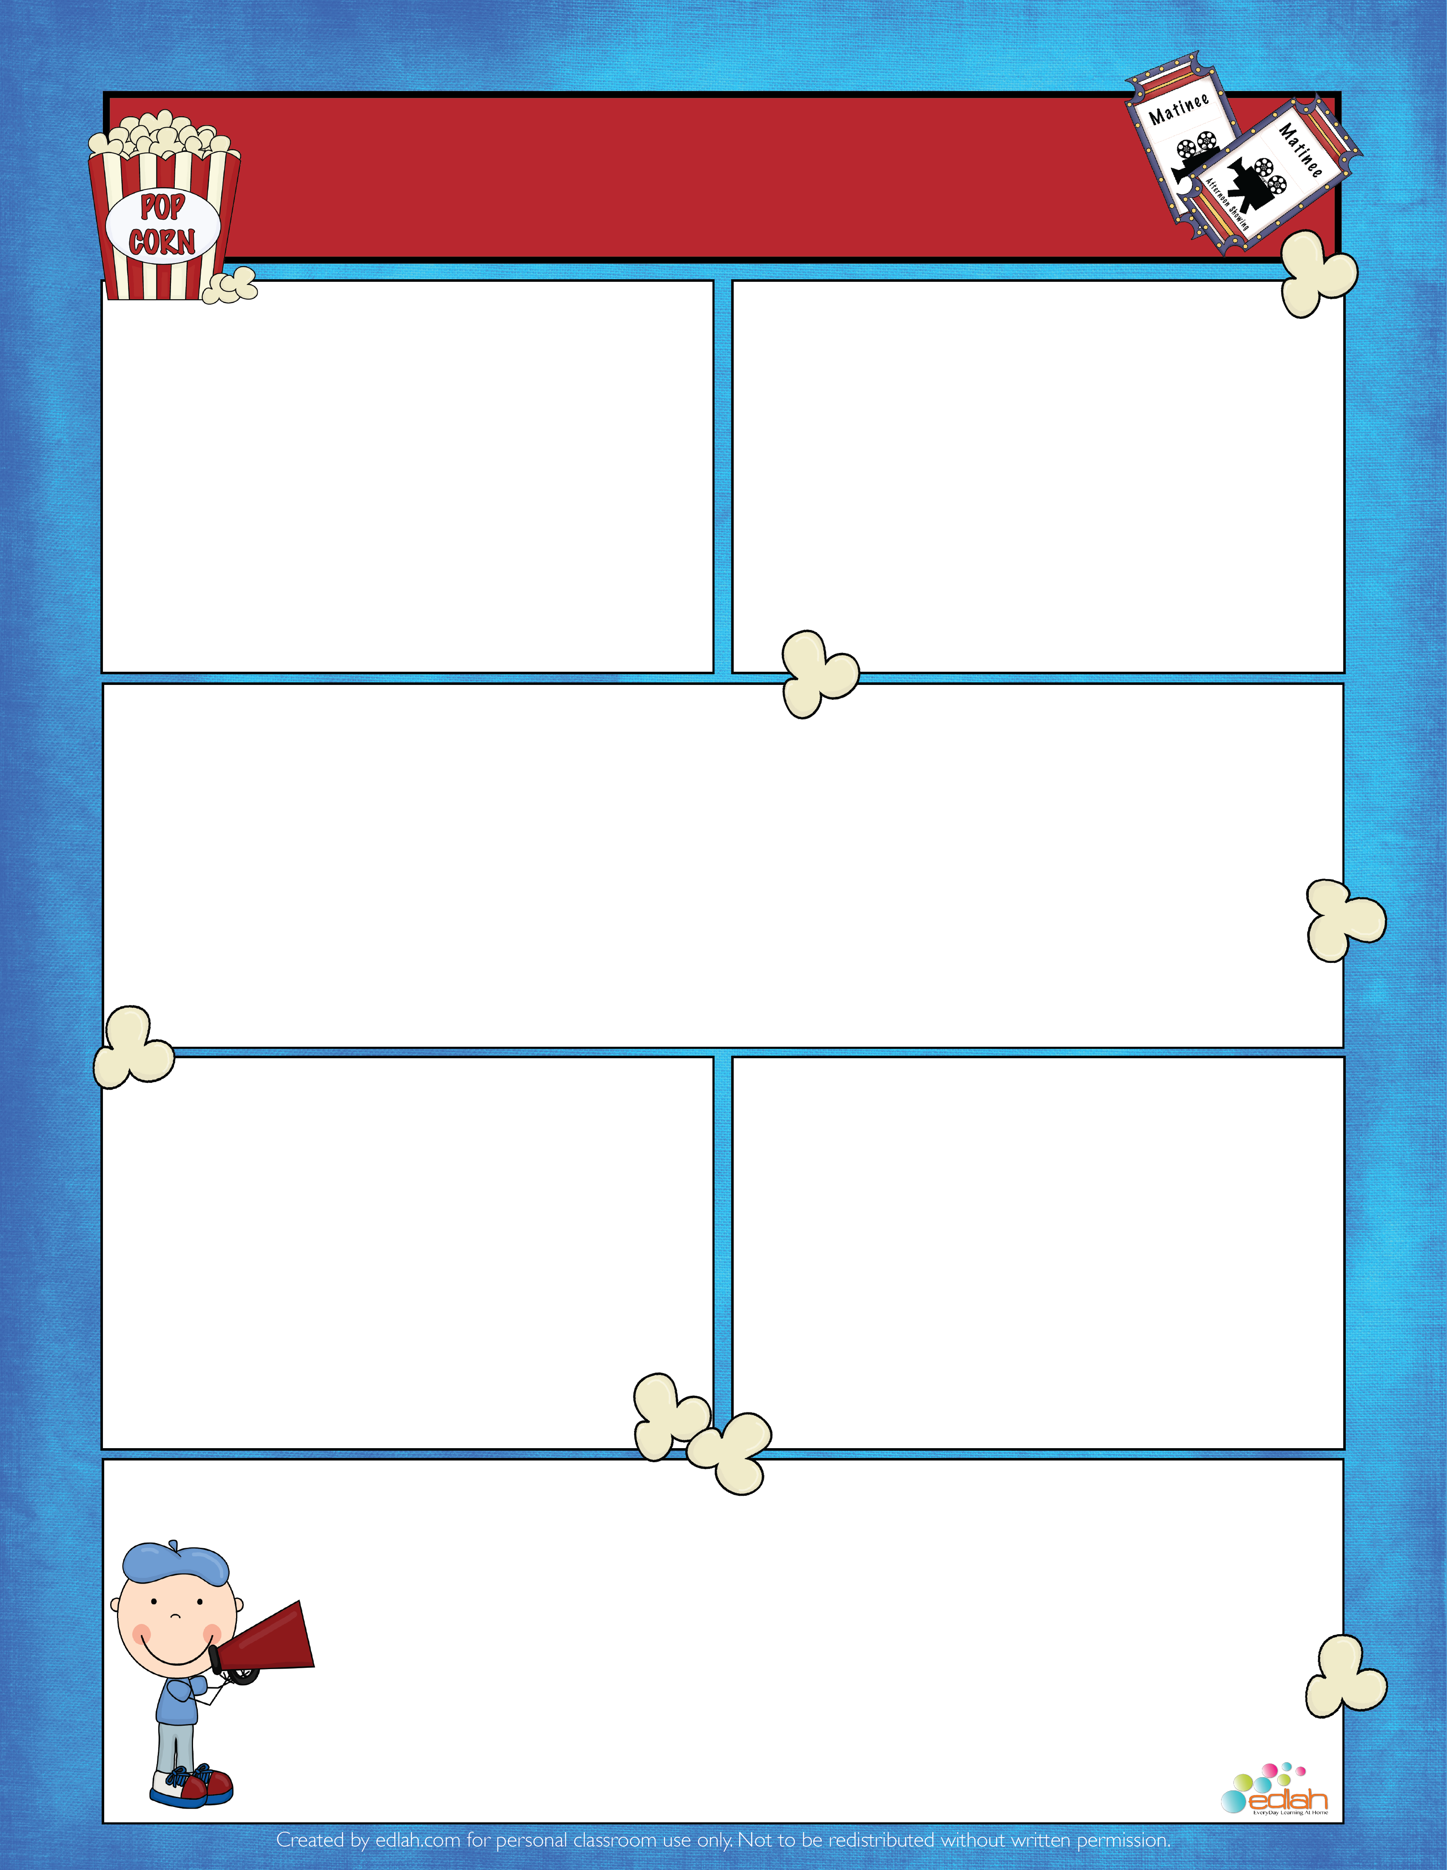

* Word study graded activity ~ Friday

SPELLING/Word Study

ENGLISH

Handwriting packet ~ complete each day’s assignments. It will be turned in on Friday. Take your time on these assignments. It should be neat and legible.

Be sure to pay your supply fee. You can pay a portion of it now and the other half later.

Book Project Movie Poster has been extended to December 2nd.

Work on root word activities for cycl, circ/circum & centr/center

This Week in ELA

November 16-20

READING

* Complete each day’s activity of reading skills on the back of this page. Due Friday
* Read for 15 minutes each night. Log on to learn2earn.org to track your minutes and earn coins.

ANNOUNCEMENTS

ASSESSMENTS

COMING SOON

November 30th Spelling Bee

November 23 – 27 Thanksgiving Holiday

December 1st ~ Chick–fil-a Night 5 to 8

December 3rd ~ 6th Grade Christmas Dance

December 7-11 ~ Santa Secret Shop